Introduction

My name is Sean Gillam, and I am a Computer Science/Math Major with a hope of transferring to UCR after fall 2022. I enrolled in this class as it is part of my required course work; however, I also really want to learn about this subject. I tried taking this class at the start of the pandemic; and, through a combination of outside life events and myself not transitioning to an online environment easily, I had to withdraw from the class. I’m really excited to be back in person, and I hope to do well in this class.

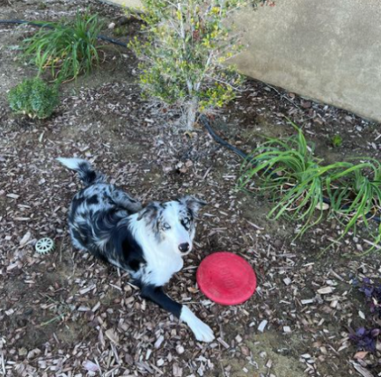 I should also mention that I am in the Army National Guard and have been since 2018. My unit has responded to a few state emergencies such as the George Floyd protest; and, more recently, we responded to assist Cal Fire with the Dixie Fire up north near Sacramento. I enjoy hiking and have been planning to do some more hikes this year in the local national parks. During most of my down time when I am not stressing about a Physics or Calc final, I play games with some of my friends online or play with my dog. My dog is a 9-month-old Border Collie Australian Shepherd mix. I also help restore cars with my dad when I have time. Most recently we restored a 1967 VW Bug.

